**Introduction**

The purpose of this project is to practice writing basic web pages with HTML and CSS and deploy them. You will have to write 2 static web pages and at least 1 CSS sheet. You can do this using a text editor such as Notepad editor. You are not allowed to use any HTML-generating tools, such as FrontPage, for any part of this project.

* The 1st (index) web page is your personal home page.
* The 2nd web page is your course page, where you can write about your current school schedule list of courses and projects/assignments.

**Part 1: Personal Home Page**

Create a page named **index.html** that describes you. On your page, include some or all of the following information (just a suggestion):

* Your name
* A short bio or description of yourself.
* A list of classes you are taking right now. Make a link to your course web page. *Hints: Use relative URLs so that links don’t break as the pages are moved. All file names are case sensitive.*
* Your 3 favorite sports, movies, books, or TV shows. Make at least one link to an interesting site.
* Two images (e.g. one of your personal pictures) or you can even use an introductory video instead.
* Include a table.
* Should use at least 10 different HTML tags

**Part 2: Personal Course Web Page**

Create a personal course web page that describes courses you took/are taking and highlight some noteworthy assignments/projects

**Part 3: Style Your Page with CSS**

Create at least 1 CSS style sheet to improve the appearance of your web pages. The pages must have the same visual structure to give the site consistency and the style sheet(s) should define different color schemes and fonts and be interchangeable (i.e. all pages should work with the stylesheet(s)). You should define the styles for each different element used in your web pages.

**[OPTIONAL] Part 4: Validate Your Page and CSS**

Validate your HTML and CSS code (through any validator of choice or following the steps below) to make sure they match the HTML specifications. To run the validators provided here, do the following:

1. Open <http://validator.w3.org/> (for HTML) or <http://jigsaw.w3.org/css-validator/> (for CSS)
2. Click Browse in the Validate by File Upload section

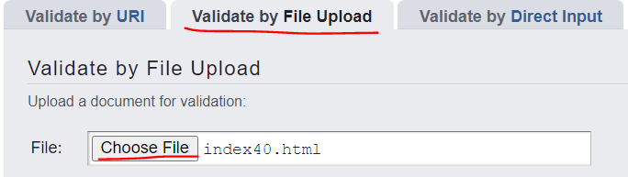

1. Locate the local file and click Open
2. Click Check
3. If there are any errors, fix the first one, then repeat steps 1 through 4.

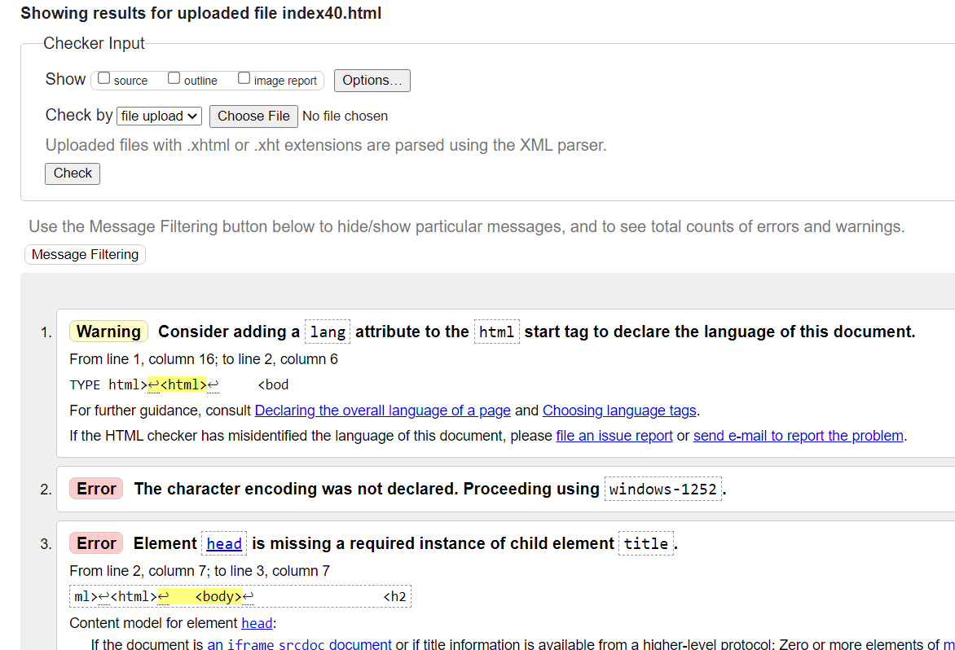

The key thing is to get the green bar saying that your page is valid HTML. If you see any yellow warnings about being *tentatively* valid, this is okay.

If there are some errors you don’t understand, you could try resolving them by troubleshooting through research or you may ignore them if they aren’t really impacting your site significantly, especially since this is not XHTML (which would otherwise require you to fix the errors) In other words, ***these validation steps are kind of optional*** ***but highly recommended!***)

**Part 5: Deploy Your Web Site using a hosting service like Amazon Web Services**

You may host your website using AWS Elastic Beanstalk, AWS S3 for static websites, Netlify, or Heroku (or any other hosting service you want to use like Microsoft’s Azure App Service, etc.).

Guides embedded below



Some key notes if you are deploying your website using the AWS Elastic Beanstalk service:

* Name your Environment in the format: **firstName-LastName-Project**, e.g. john-smith-project
* Remember to only launch **t2.micro** instances. All other instance types cost more money!
* Just create one application. If you make any changes, you can deploy a new version in your current application.
* Your main page must be named “**index**”
* Put all your html, CSS, and image files under the same folder, and zip them up. Please don’t include the parent folder in the zip file. In other words, the “index” file should be in the root directory of your zip file. Otherwise, the system will not be able to locate your files. Refer to the guide for more details.
* Terminate the environment after each use (unless I ask you leave it on for grading). It will terminate the underlying EC2 instances.

**For help getting started:**

Checkout this [HTML/CSS playlist](https://www.youtube.com/playlist?list=PLBkzRVY0qBaeDUAxtuBkIxrDb6rXhBg4A).

Sample Personal Web Page (Be as creative as you want! The more elements and styling you add, the greater it will look as a portfolio you can use to represent yourself!)

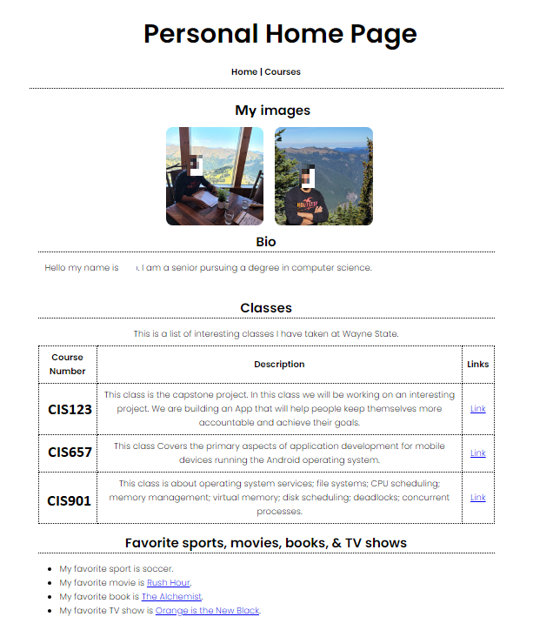

**Grading**

The grading criteria for this assignment will include: the extent to which your pages contain all the things described in the previous section, compliance to standards, the lack of broken links, the conciseness of the HTML and CSS files, and the lack of visually disturbing artifacts that make it very unpleasant to look at the pages. Your program should work in Google Chrome.

**What to turn in:**

1. Upload all your files, including source codes and image files as **a single ZIP file** to the relevant assignment.

2. Write down the URL of your web site in the comment section, when submitting.